**Deep Learning with Tensor flow**

**Deep learning**

Deep learning is a AI method that teaches computers to process data in a way that is inspired from human brain.

**Machine learning:**

Machine learning is turning data into numbers and finding pattern in those numbers.

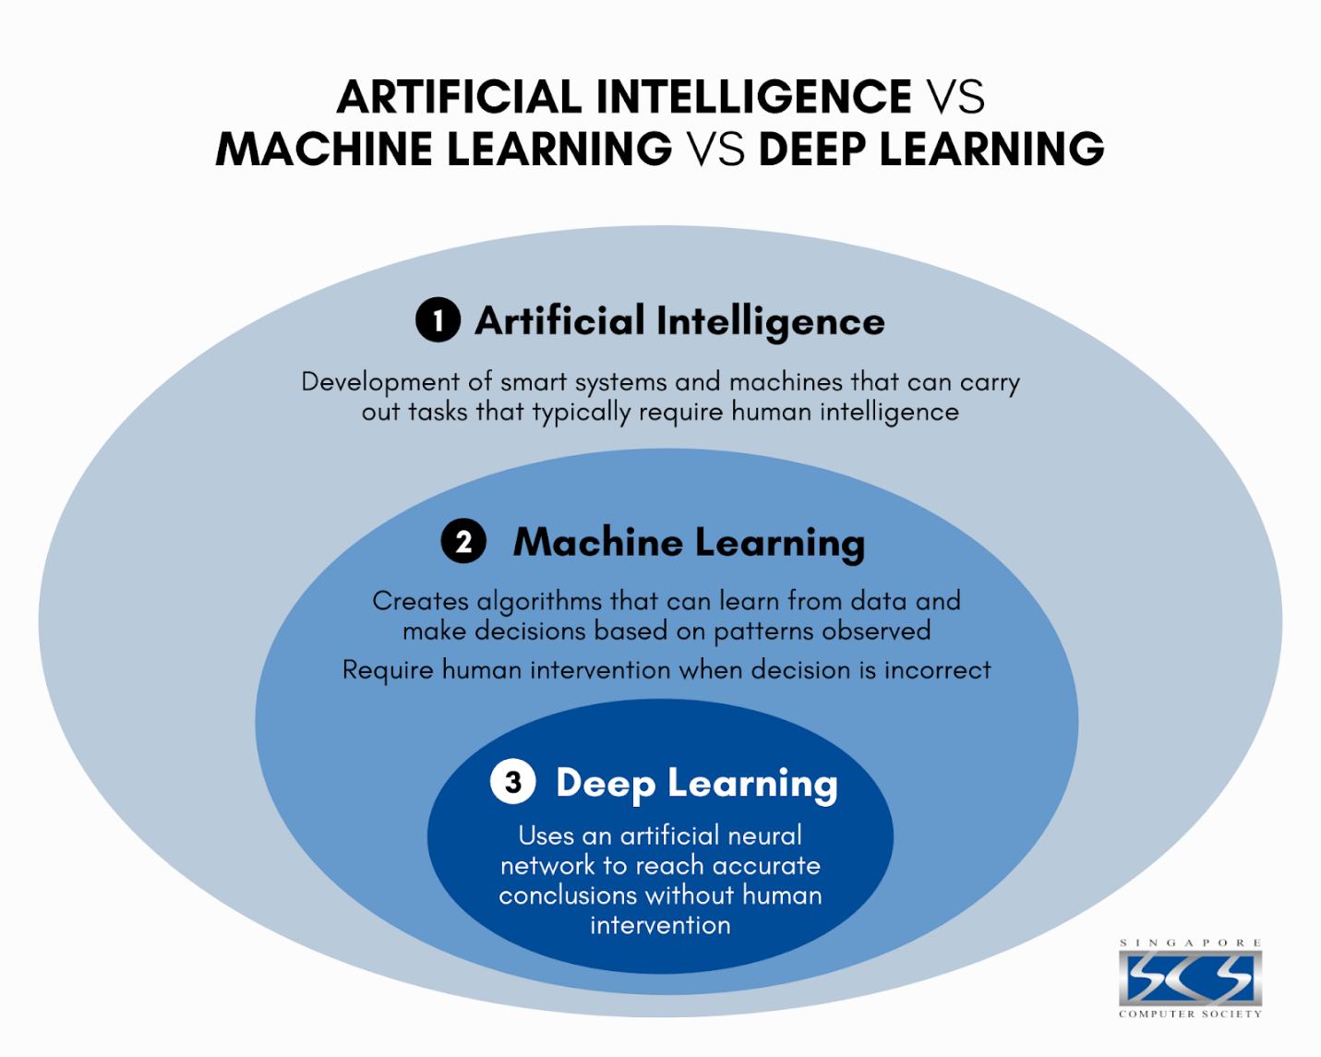

Figure 1 Artificial Intelligence vs machine learning vs deep learning

**Types of learning**

1. **Supervised learning**
2. **Semi-Supervised learning**
3. **Unsupervised learning**
4. **Transfer learning**

**Supervised learning**: it is a type of machine learning where an algorithm learns from labeled data to make predictions. It works like learning with a teacher: the system is given input data along with the correct answers, and it tries to find a pattern that maps inputs to outputs.

**Semi-Supervised learning:** type of ML that uses small amount of labelled data and large amount of unlabeled data to train a model.

**Unsupervised learning:** type of ML where model learns patterns and structures without labeled data. The model discovers patterns, similarities or hidden data on its own.

**Transfer learning:** pre-trained model is reused for a different but related task.

# **Some Deep learning use cases**

* YouTube Feed recommendation
* Google translates
* Computer vision
* Speech recognition
* Email spam detection

# Tensor flow

* End-to-end platform for ML
* Write fast deep learning code in Python and other accessible languages (able to run in GPU/TPU)
* Able to access many pre-built deep learning models
* Whole stack: preprocess data, model data, deploy model in your application
* Originally designed and used in-house by Google (now open-source)

# **Why tensor flow?**

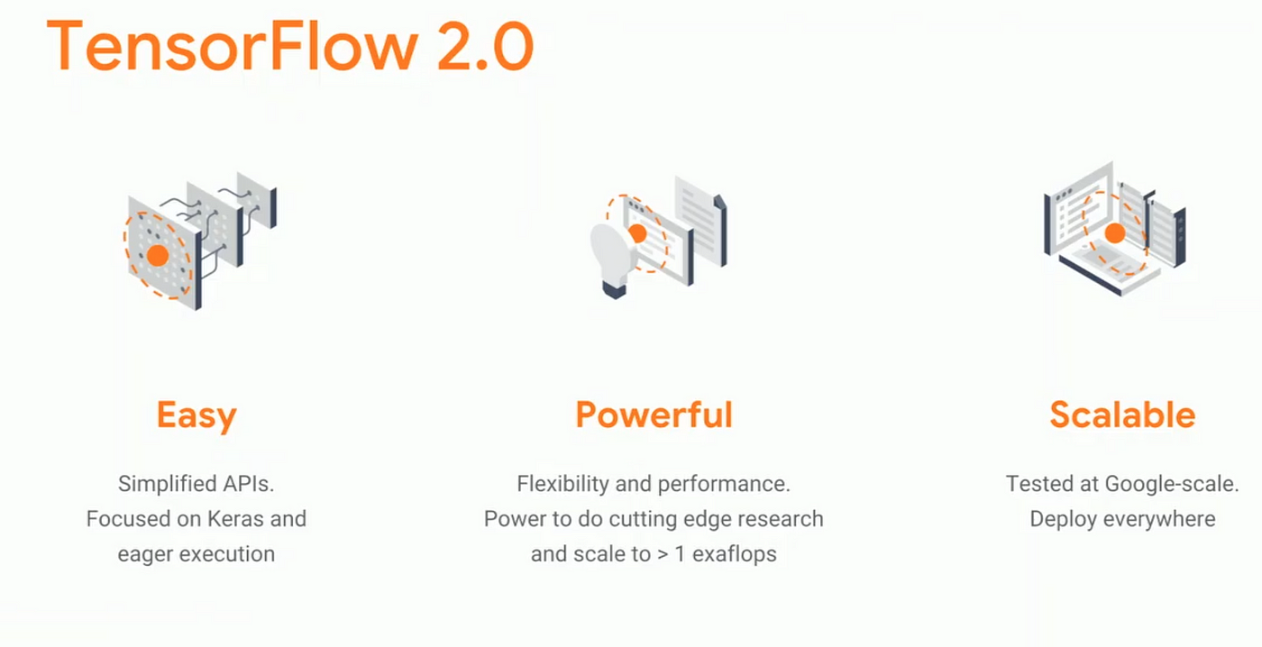

Figure 2 why tensor flow

# **What is tensor?**

Numerical way to represent information.

# **References:**

Daniel Bourke. (2021, March 16). *Learn TensorFlow and Deep Learning fundamentals with Python (code-first introduction) Part 1/2* [Video]. YouTube. <https://www.youtube.com/watch?v=tpCFfeUEGs8>

*Simplifying the Difference: Machine Learning vs Deep Learning . . .* (n.d.). www.google.com. https://www.google.com/imgres?q=deep%20learning%20vs%20machine%20learning&imgurl=https%3A%2F%2Fs3.ap-southeast-1.amazonaws.com%2Ffiles-scs-prod%2Fpublic%252Fimages%252F1605842918803-AI%2Bvs%2BML%2Bvs%2BDL.png&imgrefurl=https%3A%2F%2Fwww.scs.org.sg%2Farticles%2Fmachine-learning-vs-deep-learning&docid=CgEocNu3VPSsMM&tbnid=IR6D50Kt_CodfM&vet=12ahUKEwjV78K88sqLAxVg4jgGHetGAHYQM3oECB0QAA..i&w=1600&h=1280&hcb=2&ved=2ahUKEwjV78K88sqLAxVg4jgGHetGAHYQM3oECB0QAA

Synced. (2021, December 8). Google debuts TensorFlow 2.0 Alpha - SyncedReview - Medium. *Medium*. https://medium.com/syncedreview/google-debuts-tensorflow-2-0-alpha-ef1e01180c29